Security Concept

  - Abstract
This document provides an overview of the security measures integrated within the Project.
The signatures are on the original document of the related department.
Die Unterschriften befinden sich auf dem Original der oben genannten Fachabteilung.
  - Revision History

Rev. | Release Date | Prepared by | Change Description
0.1 | 09.02.2023 | H.Cankaya | Draft Version
0.2 | 17.03.2023 | H.Cankaya | Sections 5, 6, 7, 8 created and extended
0.3 | 11.12.2023 | Dheeraj.K | Sections 3,4,6,7,8 Updated
0.4 | 13.12.2023 | Dheeraj.K | Section 6 Updated
0.5
0.6
0.7
0.8
1.0
1.1

Responsible Head of Department: | Ulrich Nickel

  - Content

1. Introduction 5
2. Architecture 5
2.1 System Overview 5
2.2 Communication and Network Architecture 6
3. Relevant Assets and Security Goals 7
3.1 Keys, Certificates and Secrets 7
3.2 Further Assets 8
4. Security Relevant HW/SW Configuration Overview 8
4.1 HW Configuration 8
4.2 SW Configuration 10
5. Security Infrastructure 10
5.1 Secure Key Server Infrastructure Overview 10
5.2 Roles and Rights 11
5.3 Process: Store public key from RSA for Diag-hardening 12
5.4 Process: Manage public & private keys from DELTA for Diag-hardening 12
5.5 Process: Manage keys for JTAG encryption 12
5.6 Process: Manage keys for code signing 13
5.7 Process: Provision of the software by the development to the production 14
5.8 Setting up the Secure Key Server (HSM-Server) 14
5.9 Production Server 14
6. Security Measures and Processes 15
6.1 RNG Creation in the ECU 15
6.2 Secure JTAG Access 16
6.2.1 Secure JTAG Access – Production Process 16
6.2.2 Access JTAG Password in case of Warranty 17
6.2.3 JTAG Unlocking 17
6.3 Securing Diagnostic Services 19
6.3.1 Secure Diagnostic – General Information 19
6.3.2 Security Access for OEM Services (Security Access Level 1) 19
6.4 Software Privacy and Integrity Protection 20
6.4.1 SW Signing and Verification Process 20
7. Key / Bootloader Update Procedures 20
8. Delta Internal Security Diagnostic Services 21
8.1 DataServices_ Production_Sec_LockDevice_Write: 21
8.2 DataServices_ Production_Sec_LockDevice_Read: 21
8.3 Routine Control : 31 01 FF B0 22
9. Abbreviations and glossary 23

Introduction
This document provides an overview of the security measures provided in the Renault 5DH DC-DC Sweet_400 ECU.

Architecture
This chapter explain the architecture of the ECU including the backend components.

System Overview
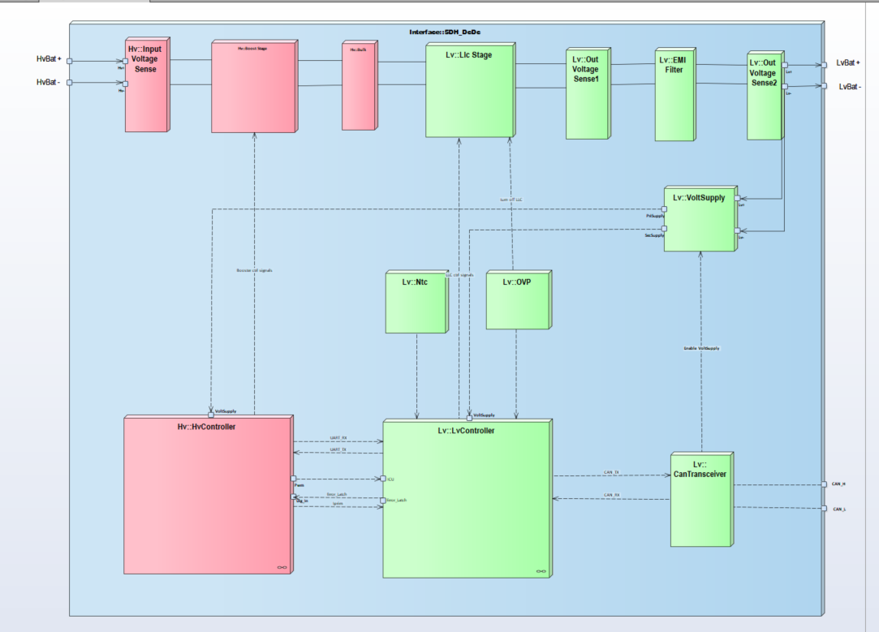

Figure 1: System Overview

Communication and Network Architecture
This clause intentionally left blank.

Relevant Assets and Security Goals

Keys, Certificates and Secrets
 | # | Key ID | Storage in ECU | Storage in Infrastructure | Dev Variant Existis | Series Variant Exists | Responsible | Key Type | Lifecycle | Plain Readable from Host | Writeable only Once | Persistent | Notes
---- Keys ---- | A.1 | Keypair_Delta_JTAG_Password_Encryption | Public Key stored as part of BTLD SW Code (Part is set to OTP) | Key pair stored in HSM-Server | x | x |  | RSA 2048 Bit
---- Keys ---- | A.2 | Keypair_Delta_SecureDiag | Public Key stored as part of BTLD SW Code (Part is set to OTP) | Key pair stored in HSM-Server | x | x |  | RSA 2048 Bit
---- Keys ---- | A.3 | Keypair_Delta_SWSigning | Public Key stored as part of BTLD SW Code (Part is set to OTP) | Key pair stored in HSM-Server | x | x |  | RSA 2048 Bit
---- Keys ---- | A.4 | Keypublic_Renault_SecureDiag | Public Key stored as part of BTLD SW Code (Part is set to OTP) | - | x | x |  | RSA 2048 Bit
Table 1 - Assets Storage Overview

Further Assets
This clause intentionally left blank.

Security Relevant HW/SW Configuration Overview

HW Configuration

Debug Interface Protection configuration for JTAG Locking
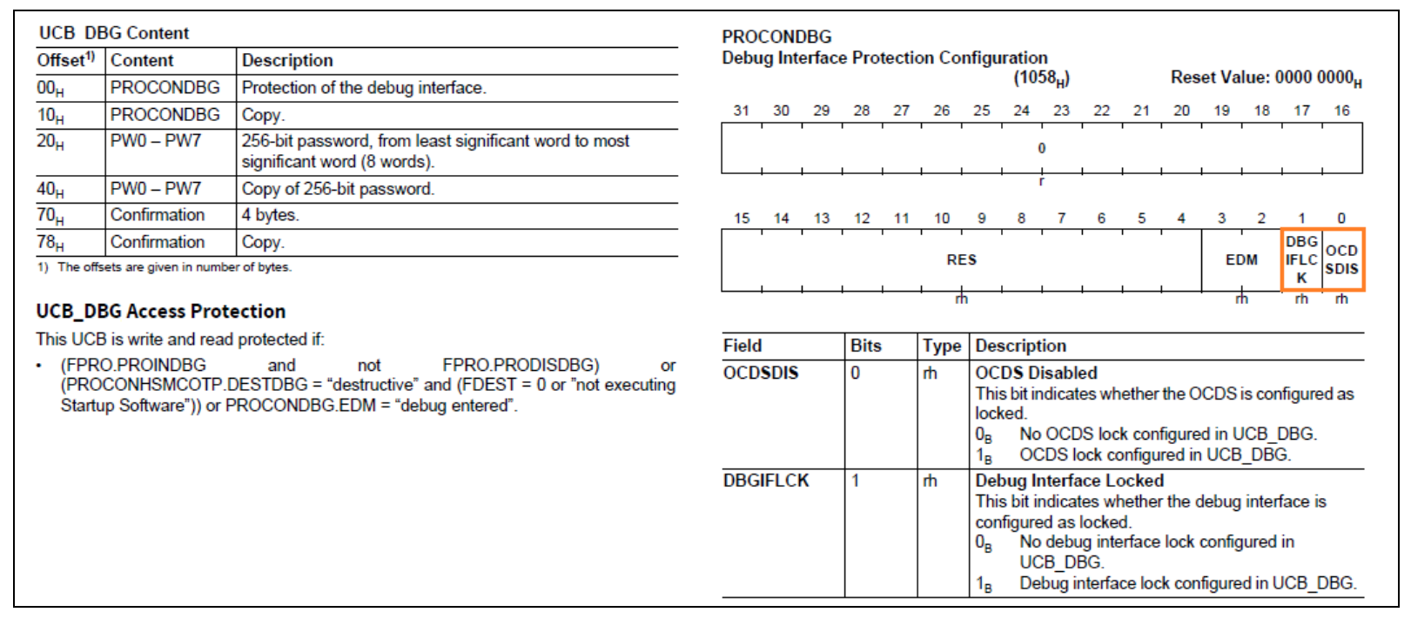

Debug Interface Unlocking Utility in Debugger
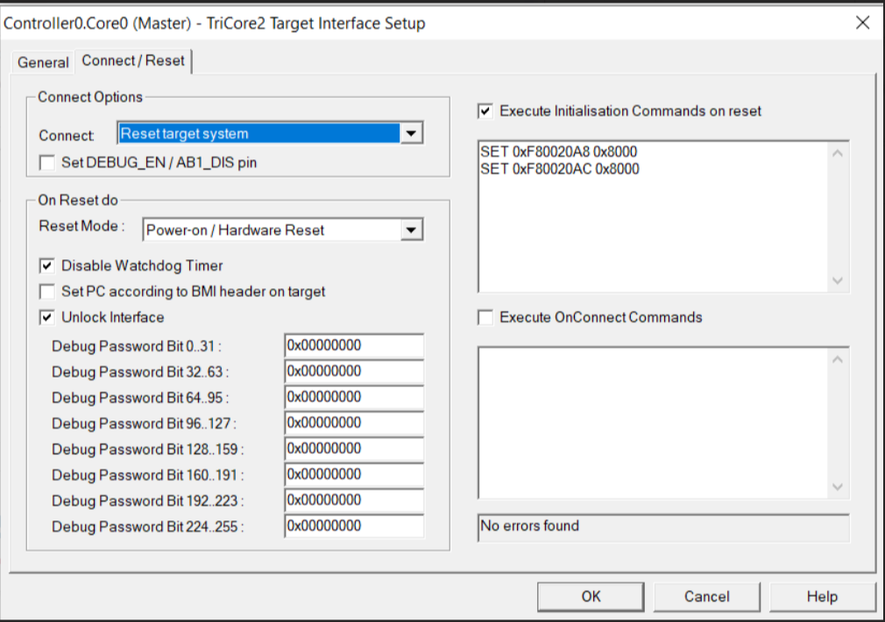

Public Keys used in the SW
Key Name | Start Address | End Address
Self_Check Key | 0xA001C226 | 0xA001C325
DiagSecH_SecAcc Key | 0xA001C106 | 0xA001C205
JTAG Key | 0xA001C000 | 0xA001C0FF
Note : These addresses are located in OTP section.

SW Configuration
This clause intentionally left blank.

Security Infrastructure

Secure Key Server Infrastructure Overview
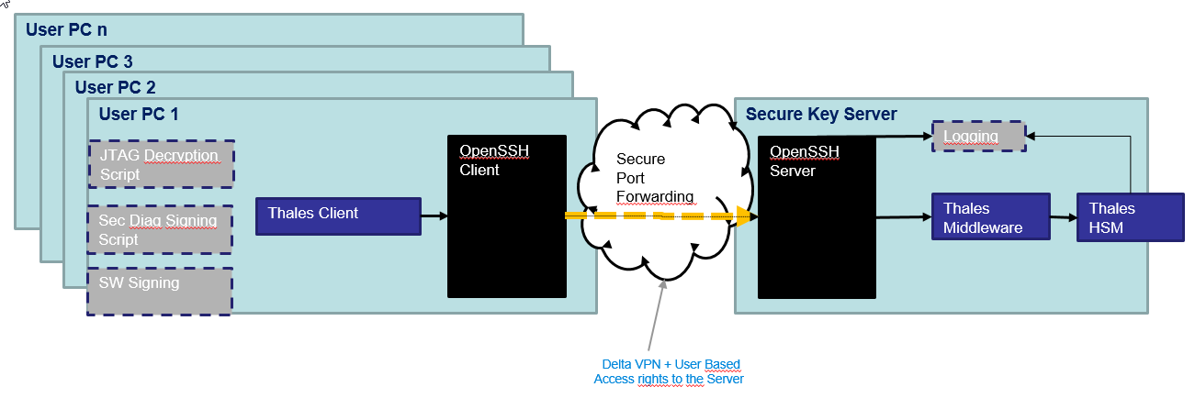

Roles and Rights
 | Role
Functionality
 | IT Admin | Security Admin | Backup Responsibles | User Role “Warranty Responsible “ | User Role “Secure Diag Responsible” | User Role “SW Signing&Encryption Responsible” | Role “Build Server”
Configure Port Access for user to Secure Server | X
Add Public Key of User to Openssh Server | X
Initial Configuration of the HSM (Create User and Create keys) |  | X
Initiate Backup Information (m of n) |  | X
Recreate HSM Content |  |  | (3 of 6)
Change Own HSM Access Password |  | X |  | X | X
Sign Secure Diag Message (Sign with Keypair_Delta_SecureDiag via HSM) |  |  |  |  | X
Decrypt JTAG Password (Decrypt with Keypair_Delta_JTAG via HSM) |  |  |  | X
Trigger Build Server for signing and encrypting SW |  |  |  |  |  | X
Sign SW (Sign with Keypair_Delta_SWSigning via HSM) |  |  |  |  |  |  | X
Read Logs | X (on Server) | X (on HSM & on Build Server)

Process: Store public key from RSA for Diag-hardening
The public key Keypublic_Renault_SecureDiag is received by the Delta Security Officer and stores the public key in the project SVN.

Process: Manage public & private keys from DELTA for Diag-hardening
The key pair for the generation and verification of the security access response is created by Delta in the secure key server. The private key does not leave the secure key server. The public key is part of the bootloader image.
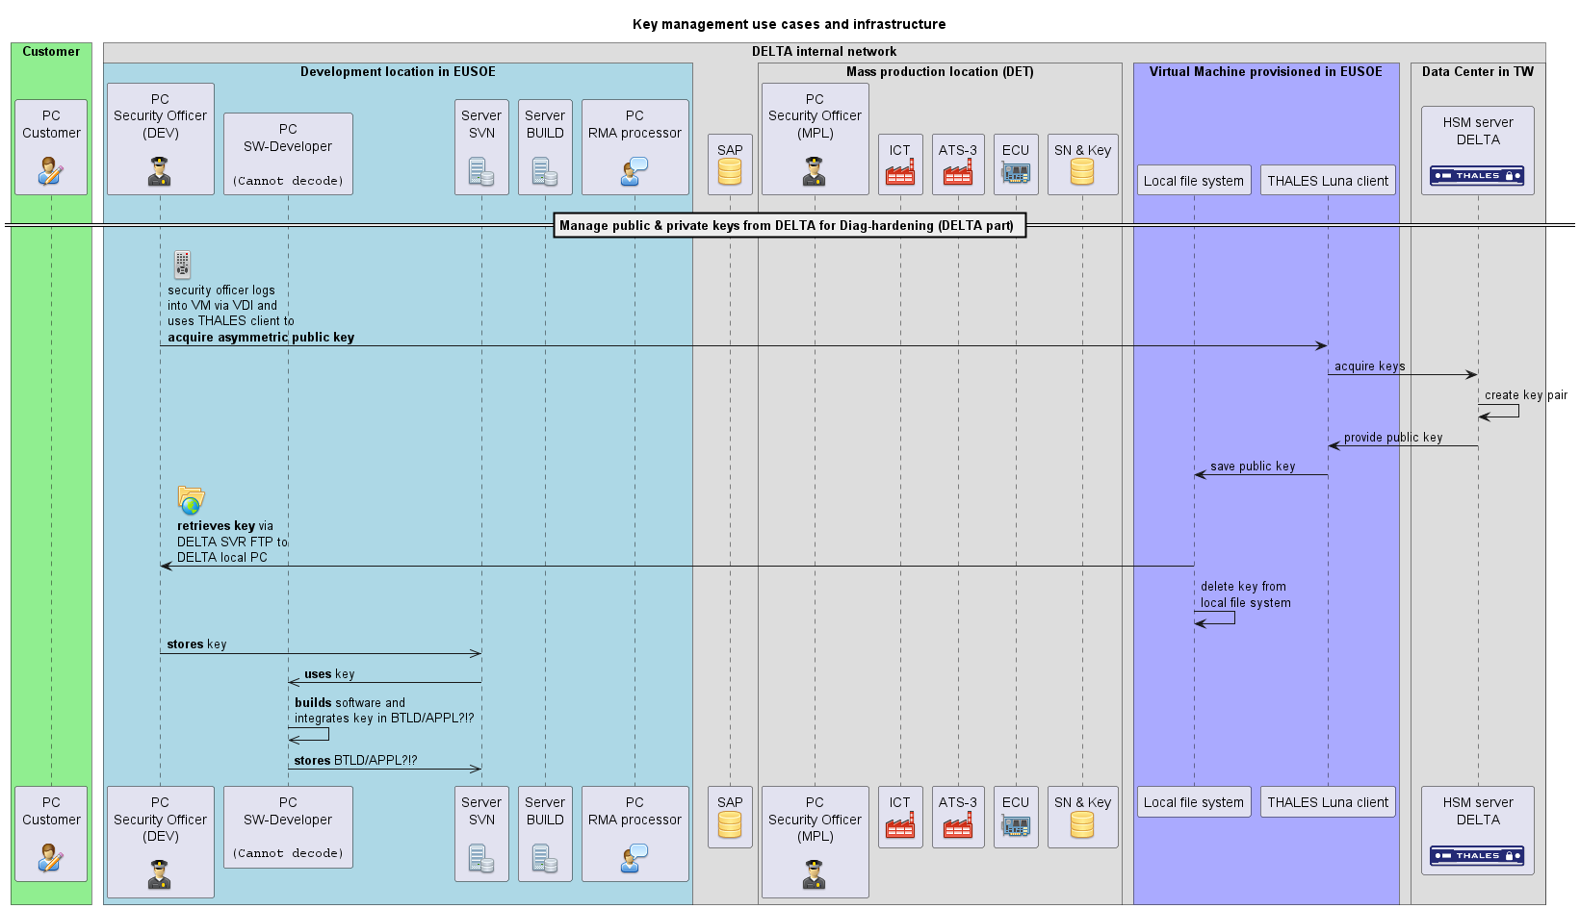

Process: Manage keys for JTAG encryption
The JTAG password encryption key pair is created within the secure key server. The public key is stored in the bootloader code and is part of the bootloader image.
For more information on the use of the public and private key please refer to section 6.2.
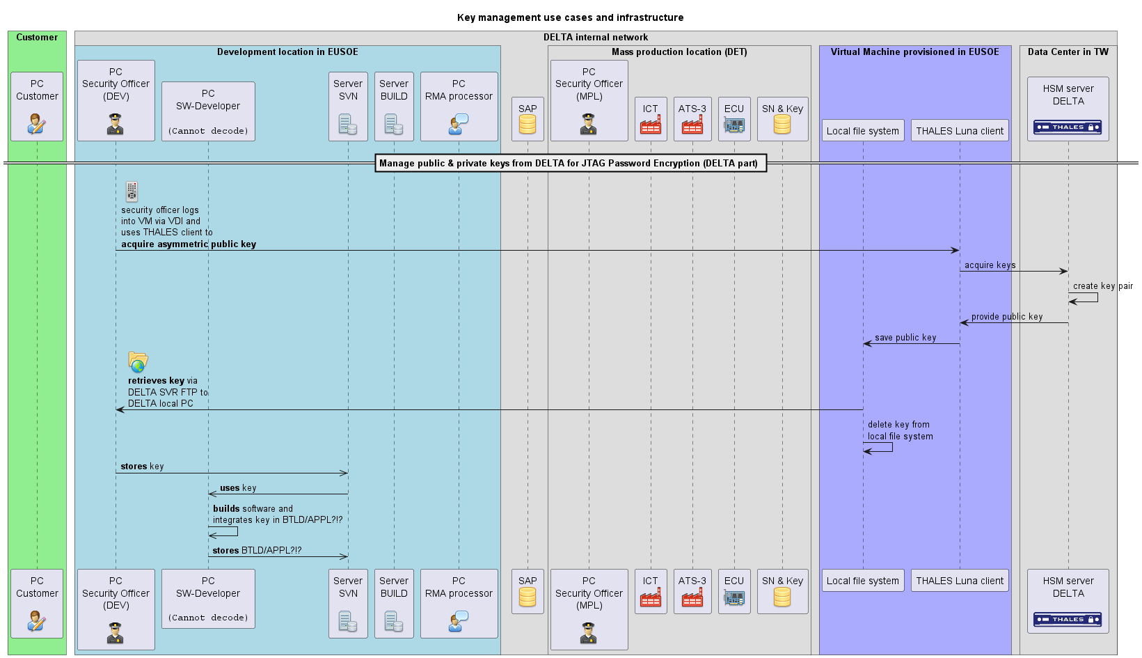

Process: Manage keys for code signing
The SW Code Signing key pair is created within the secure key server. The public key is read out from the HSM server by the build server and added to bootloader image during the build process. The build server has secure access to the secure key server and can sign SW images with the code signing key.

Process: Provision of the software by the development to the production
The software development team is located at DES and will provide the final built software via DELTA’s internal IT network to the mass production location in DET as part of the BOM. The BOM is stored in the internal SAP system. The final software mainly consists out of three software package, the bootloader (BTLD), the application software for production (APPL_production) and series application software (APPL_series). DET will retrieve the software and provide it to the specific production stations, e.g. ICT or ATS. At ICT or ATS, the software will be flashed into the electronic control unit (ECU):
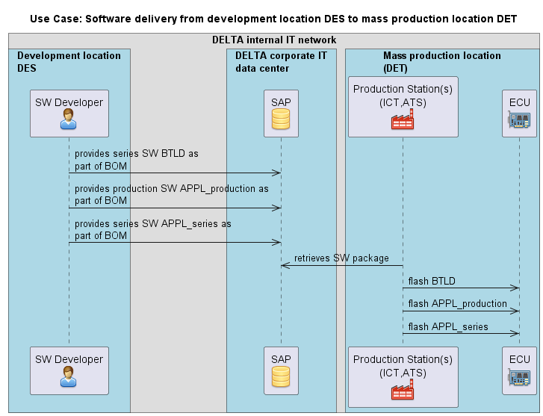
Figure 1: Provision of the software by the development to the production, [use_case_sw_to_mpl.png].

Setting up the Secure Key Server (HSM-Server)
This is performed by DELTA corporate IT.

Production Server
For some processes a local server for the production site is needed.
The Production Server is used for following processes
- Store Encrypted JTAG Password
- Read Encrypted JTAG Password for specific Serial ID’s

Security Measures and Processes

RNG Creation in the ECU
The ECU does not have a hardware security module for providing trustable entropy for a random number generator. The current approach to create random numbers is following.
- The random number is created with the PRNG algorithm provided by the Vector Crypto Module Crypto_30_LibCV.
- The random number is created according to FIPS 186-2.
- The PRNG is seeded at every random number generation with the current timer value XOR serial number of the device from the HW timer. The HW timer is running in the same frequency as the processor and has 32 bits length. The serial number is a constant device specific 20 byte long data.

Secure JTAG Access

Secure JTAG Access – Production Process
The JTAG interface is locked during the production at Delta. The JTAG is locked by the processor UCB configuration and the restriction is assured by the HW measures of the processor. JTAG can be unlocked by a 256 bit password. The password is created randomly internally in the ECU during the production process at Delta, see clause 6.1. The password is then encrypted with public key of Keypair_Delta_JTAG_Passwod_Encryption and sent to the production station. The production station stores the encrypted JTAG password in the local secure production server.
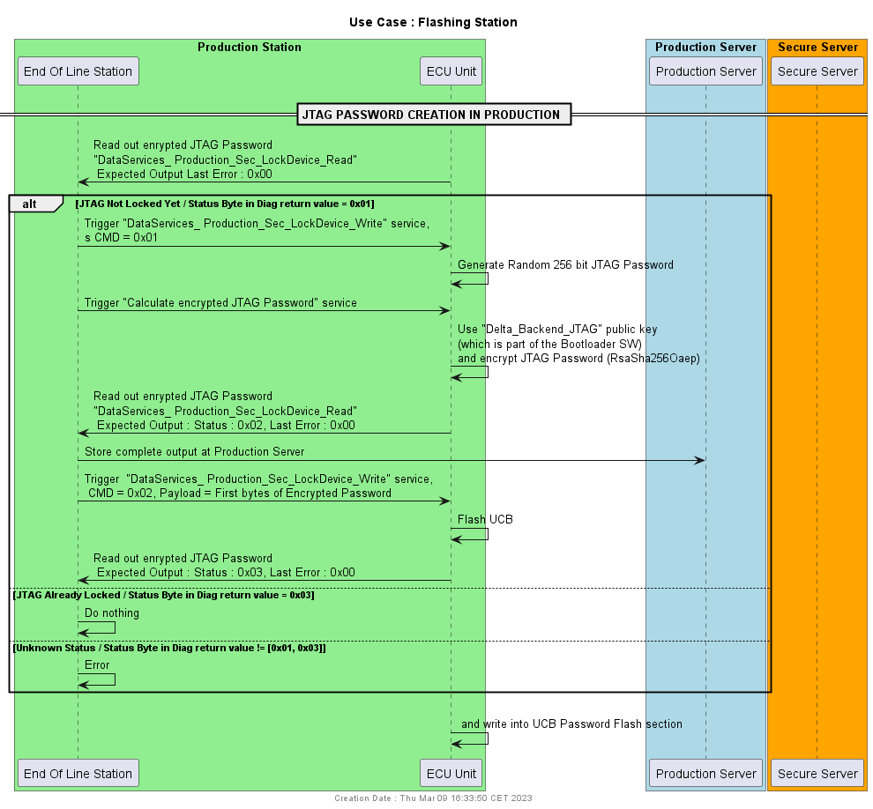
Figure 2 - JTAG Locking at Production

Access JTAG Password in case of Warranty
The JTAG password can be recovered by the security officer by performing the following steps:
- Read the unique ID of the device
- Retrieve the encrypted JTAG password from the production server
- Decrypt the JTAG password with the help of the HSM server

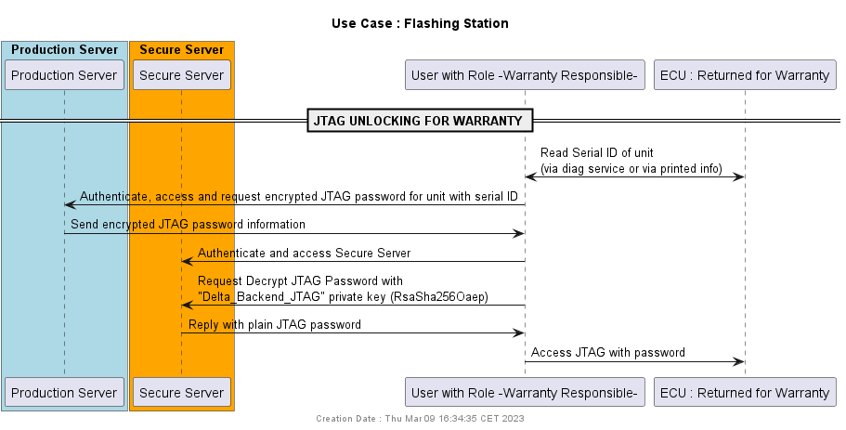

JTAG Unlocking
The JTAG interface can be unlocked with the correct password. Precondition is that the password for the specific device has to be retrieved as described in section 6.2.2. The password has to be added into the Debugger tool, and unlock the interface while the debugger connects to the JTAG interface. Please refer to the user manual of the debugger tool for further details.

Securing Diagnostic Services

Secure Diagnostic – General Information
Some diagnostic services can only be executed once a specific security level is activated. The UDS service “Security Access” (0x27) is used to activate the security level.
- Security Access OEM Level 1 services $27 01, $27 02
The following sections define which diagnostic services are protected by the security access.

Security Access for OEM Services (Security Access Level 1)
The following diagnostic services are only accessible in the OEM diagnostic session:
- $2E : All Write DataByIdentifier service with DiagTool
- $31 : All Routine control service with DiagTool
- $10 : Programming Request with DiagTool
- $11 01: ECU Hard Reset via DiagTool

Software Privacy and Integrity Protection

SW Signing and Verification Process
The software signing process is described in clause 5.6.
The SW update and verification process in the ECU is described as following
- ECU is running in Application
- Security Access in OEM session
- Run diag service to switch to BTLD mode (only accessible in OEM session)
- Receive flashing request and header containing information of SW package and the signature
- Store seed in NvM
- Start Download Request : Erase Flash
- Set existing Application to invalid
- Receive SW chunks and flash them in the Application Flash area
- Verify Signature of flashed SW
- Set Application to Valid if Signature is valid
- Reset
- Start new Application

Key / Bootloader Update Procedures
The bootloader image incorporates the following assets.
- Keypair_Delta_JTAG
- Keypair_Delta_SecureDiag / Keypublic_Renault_SecureDiag
- Keypair_Delta_SWSigning

Until the series keys are created in the secure key server at Delta, we will proceed using development keys.
An Update of the Bootloader is only planned for updating from a development bootloader (containing development keys) to a series bootloader (containing series keys). A bootloader updater for the series devices is not planned, therefore a downgrading from series to development is not planned.
Once the Bootloader is updated from development to series, all keys can be updated to the series key.

Delta Internal Security Diagnostic Services

DataServices_ Production_Sec_LockDevice_Write:
Start ->
DID : FFC0
Preconditions :
- ECU in Virgin Mode
- is running in Bootloader
Byte | Meaning | Value
0 | Command | 0: Do nothing  1: Generate Jtag Password  2: Flash Jtag Password and Lock Device
1..12 | Payload | In case of CMD = 0x01 -> Payload = magicword = 0x11 0xDD 0x34 0x91 0x00 0x00 …  In case of CMD = 0x02 -> Payload = First 12 bytes of Encrypted Password (see DataServices_ Production_Sec_LockDevice_Read)

DataServices_ Production_Sec_LockDevice_Read:
Read ->
DID : FFA0
Preconditions :
- ECU in Virgin Mode
- ECU is running in Bootloader
Byte | Name | Meaning | Value
0 | Status | States the status of the JTAG locking state | 0x01 : Not Locked  0x02 : Password generated and encrypted, Not flashed yet in UCB, device not locked yet  0x03 : JTAG Locked  Else : Not Known
1 | Last Error | Error from last Call of RoutineControl_ Production_Sec_LockDevice_Start | 0x00 : No Error  0x01 : Password generation error  0x02 : Encryption Error  0x03 : Flashing JTAG Password Error  0x04 : Command Content Wrong  0x05 : No valid Serial ID (e.g. still default value)  0x06 : Device already locked, no passwprd creation or flashing possible  0xFF : General Error
2 – 21 | Serial Number | 20 Bytes Serial ID of Device
22-29 | Pub Key | First 8 bytes of the Public key used to encrypt the Password
30-305 | Encrypted Password | 256 byte encrypted SerialID + Password | If not existing = 0x00 …. 0x00

Routine Control : 31 01 FF B0
Using 256 Bytes of Public Key, This Routine Encrypts the generated 32 Bytes password into 256 Bytes.

Here 31 01 is the Routine Control STRT and FF B0 is the Routine Identifier.

Abbreviations and glossary
Abbreviation or Term | Description
ATS | Automated Test System
BOM | Bill of Material
DES | Development location in DELTA Soest, Germany
DET | Mass production location in DELTA Thailand
ECU | Electronic Control Unit
ICT | Integrated Circuit Tester

The password in the UCB register cannot be read out anymore once JTAG locking is activated.

